The 8th International Conference on Multibody System Dynamics

June 16-19, 2026, Sevilla, Spain

# Instructions for Preparing an Abstract for

**the 7th International Conference on Multibody System Dynamics**

## Name1 A. Surname1*∗*, Name2 B. Surname2#, Name3 C. Surname3†, Name4 D. Surname4†

*∗* Mechanical Engineering University of Multibody Dynamics Address, Postal code, City, Country email1@address

# Institute for Mechatronics University of Tech

Address, Postal code, City, Country email2@address

†Institute of Mechanics University of Technology

Address, Postal code, City, Country [Surname3.Name3, Surname4.Name4]@address

## Abstract

Authors are requested to submit an abstract of a maximum of two pages (including references and figures) no later than **Dec 12, 2025**. The uploaded file must be in the PDF format and the file name should conform to the following example: Surname1Surname2Surname3_abstract.pdf.

The abstract must be written in English. It must contain the full names, addresses and e-mails of the authors. In case of joint authorship, the name of the speaker who will present the paper at the conference should be underlined. The reference marks can be omitted if all authors are from the same affiliation.

The equations must be numbered continuously using right flushed Arabic numbers in brackets as shown in Eq. (1):

|  |  |  |
| --- | --- | --- |
|  |  | (1) |

All symbols that appear in an equation should be explained.

Figures and graphs must be included using the same style as shown in Fig. 1. The contents of the figure should be explained in its caption.

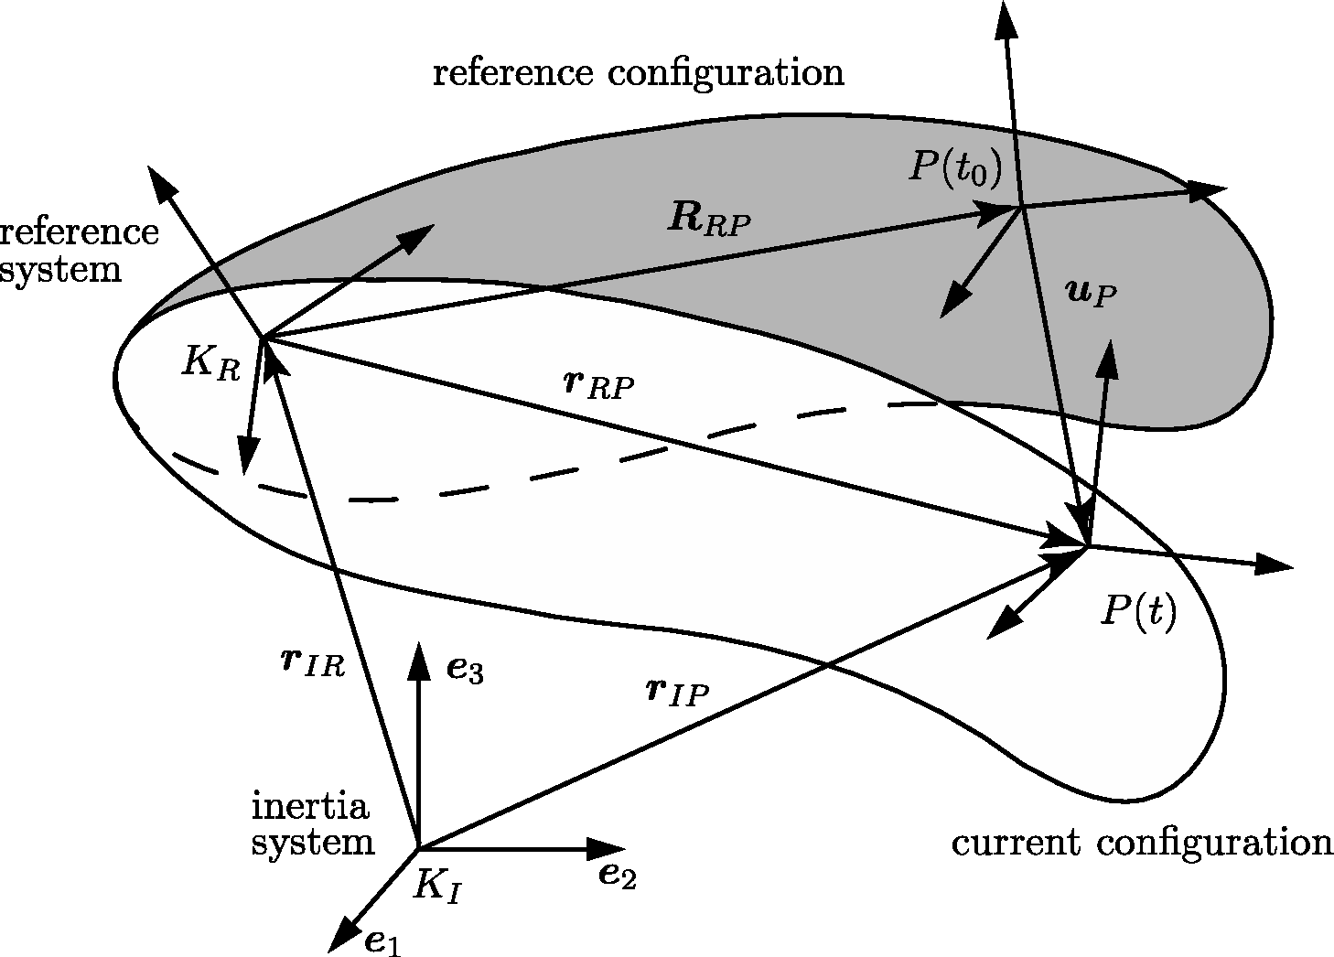

Figure 1: Example of a figure and its caption.

Tables should be included using the same style as shown in Table 1. The contents of the table should be explained in its header.

Table 1: Example of a table.

|  |  |  |  |
| --- | --- | --- | --- |
| T11 | T12 | T13 | T14 |
| T21 | T22 | T23 | T24 |

The references should be sorted in alphabetical order as shown below, where [1] exemplifies the case of a textbook, [3] is an article in conference proceedings, and [2] is a journal article.

## References

1. Bauchau, O.A.: Flexible Multibody Dynamics. Dordrecht: Springer, 2011.
2. Mikkola, A.M.; Shabana, A.A.: A Non-Incremental Finite Element Procedure for the Analysis of Large Deformation of Plates and Shells in Mechanical System Applications. Multibody System Dynamics, Vol. 9, No. 3, pp. 283–309, 2003.
3. Seifried, R.; Schiehlen, W.: Computational Analysis and Experimental Investigation of Impacts in Multibody Systems. In P. Eberhard (Ed.) IUTAM Symposium on Multiscale Problems in Multibody System Contacts, pp. 269–280, Springer, 2007.