The 8th International Conference on Multibody System Dynamics

June 16-19, 2026, Sevilla, Spain

# Instructions for Preparing a Full Paper for

**the 7th International Conference on Multibody System Dynamics**

## Name1 A. Surname1*∗*, Name2 B. Surname2*#*, Name3 C. Surname3*†*, Name4 D. Surname4*†*

*∗* Mechanical Engineering University of Technology Address, Postcode City, Country email1@address

*#* Institute for Mechatronics University of Technology Address, Postcode City, Country email2@address

*†*Institute of Mechanics University of Technology Address, Postcode City, Country

[Surname3.Name3, Surname4.Name4]@address

## ABSTRACT

The title of the paper should be typed in 12pt bold font and centered. It should be separated from the conference name by a 12pt space and from the author names by a 14pt space. Author names should be typed in bold font, and the name of the presenting author should be underlined. The names should be separated from the affiliations by 16pt space. Affiliations should be typed in general formatting style, centered within a corresponding bounding box. The abstract part of the final paper should be formatted as one paragraph not longer than 300 words and it should fit on the title page. The abstract begins with the “ABSTRACT” header typed in bold 10pt font and is separated from the affiliations by a 18pt space. The abstract text should be separated from the header by a 10pt space. The title, affiliations and abstract have to fit on the title page.

## INTRODUCTION

All text should be written in the Times New Roman font. General text should be justified and divided into logical paragraphs separated by 10pt spaces. Single line spaces are required. All section headers except the Abstract and References header should be numbered using Arabic numbers without a trailing dot. The headers are separated from the last preceding paragraph by a 24pt space and the following text by a 10pt space. Top level headers should be typed in capital characters. Subsections should be numbered using multilevel numbering. A maximum of two sublevels is allowed. Subheaders should be typed in normal word case. A font size of 10pt should be used if not specified otherwise. The subsection headers are separated from the last preceding paragraph by a 12pt space and the following text by a 6pt space.

## GENERAL INSTRUCTIONS

The paper must be written in English. The top page margin should be 18mm, the others should be 30mm. The paper used should have the size 210 x 297mm which is the European A4 size.

## Equations

The equations must be numbered continuously using right flushed Arabic numbers in brackets as shown in in Eq. (1):

|  |  |  |
| --- | --- | --- |
|  |  | (1) |

All symbols that appear in an equation should be explained.

## Figures and tables

Figures and graphs must be included using the same style as shown in Fig.1. The contents of the figure should be explained in its caption.

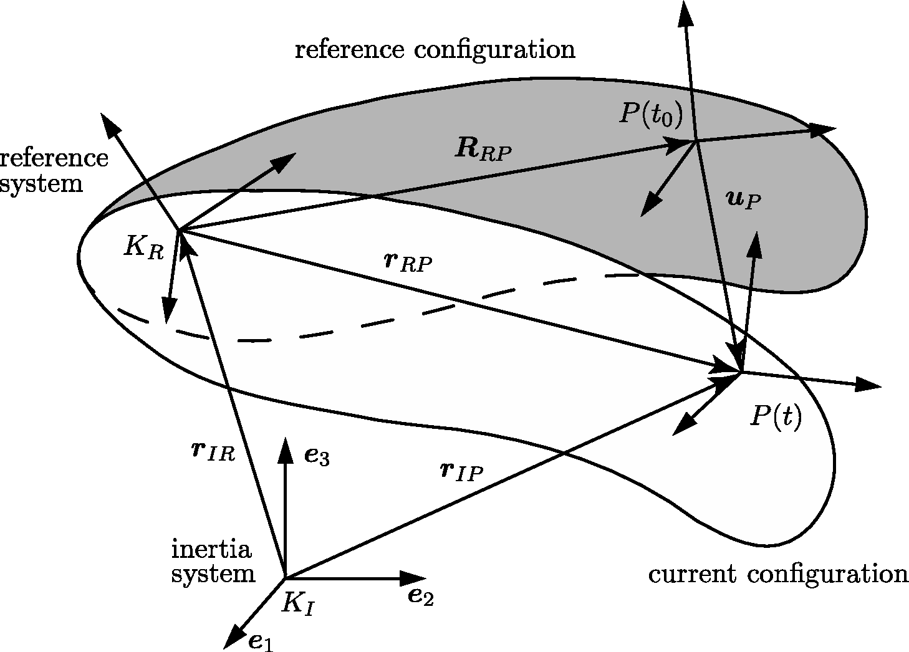

**Figure 1**. Example of a figure and its caption.

A resolution of 300dpi for pictures and 600dpi for line art is suggested, 1px wide lines in figures should be avoided as they may become invisible in print. Figures should be centered on the page.

Tables should be included using the same style as shown in Table1. The contents of the table should be explained in its header. Tables should be centered.

**Table 1**. Example of a table.

|  |  |  |  |
| --- | --- | --- | --- |
| T11 | T12 | T13 | T14 |
| T21 | T22 | T23 | T24 |

## References

The references should be sorted in alphabetical order as shown below, where [1] exemplifies the case of a textbook, [3] is an article in conference proceedings, and [2] is a journal article.

## Submission of the paper

Authors should upload the manuscript no later than March 20, 2026. The uploaded file must be in the PDF format and in principle should confirm to the submission rules followed by submissions to the Multibody System Dynamics journal. This recommendation is motivated by the observation that some of the full-paper submissions will be selected for a special issue of the Multibody System Dynamics journal. When creating the PDF, please make sure to use A4 as paper size. The file name should conform to the following example: Surname1Surname2Surname3_fullpaper.pdf.

## CONCLUSIONS

We look forward to hosting you in Madison!

## REFERENCES

1. Bauchau, O.A.: Flexible Multibody Dynamics. Dordrecht: Springer, 2011.
2. Mikkola, A.M.; Shabana, A.A.: A Non-Incremental Finite Element Procedure for the Analysis of Large Deformation of Plates and Shells in Mechanical System Applications. Multibody System Dynamics, Vol. 9, No. 3, pp. 283–309, 2003.
3. Seifried, R.; Schiehlen, W.: Computational Analysis and Experimental Investigation of Impacts in Multibody Systems. In P. Eberhard (Ed.) IUTAM Symposium on Multiscale Problems in Multibody System Contacts, pp. 269–280, Springer, 2007.